Welcome
Welcome to the July 2021 Timpenny Newsletter, I hope you find the newsletter informative and helpful. Management thought it would be a good time to remind members that now is a good time to do the maintenance on your boat and trailer during these difficult times of being locked down due to the Covid epidemic.
What a season we had through 2020/2021, many races were cancelled through Covid lockdown or bad weather, we could not take a trick in Victoria. I think NSW members experienced similar weather hassles.
This newsletter covers two tropical subjects namely man overboard and maintenance of boat trailers. With just two people on board a trailer sailor it is very difficult to pick up a person should one fall overboard particularly if only one left on board the boat and further complicated should that person in the water be injured. On the other hand, a ladder at the back of most Timpenny Boats makes it easy to get back onboard providing the MOB is okay.
Trailer maintenance is an important part of an enjoyable experience on the water with safe transportation of the boat to and fro.

Presidents Report
Good day all members. What a difficult year we are experiencing, and the way the covid spreading we may have a little further to go. However, it does give us a great opportunity to do those little jobs that we put off for a later day.
In this newsletter we have tried to cover the forth coming events, maintenance, a bit of theory and past events.
The committee is working with Australian Sailing with CBH matters as they have taken over this function from the previous management but the new handicaps have serious ramifications unless properly addressed. (See below)
I know it is difficult times, but I know that things will eventually change for the better and next season will be here very shortly.
Take care,

Alex Shroud

2021-2022 Traveller Series
Notice of Series

 | Date | Club | Event Details | Results
1 | 13 Nov 2021 | Geelong Trailable Yacht Club | Pelican Race Geelong
2 | 4 Dec 2021 | Port Albert Yacht Club | Arount Sunday Island Trailable Yacht Race
3 | 29 Jan2022 | Warneet Motor Yacht Club | Warneet Around French Island Race (WAFIR)
4 | 19-20 Feb 2022 | Royal Melbourne Yacht Squadron  Melbourne Trailable Yacht Club | Victorian Trailable Yacht and Sports Boat State Championships
5 | 12 Mar 2022 | Gippsland Lakes Yacht Club | Marlay Point Overnight Race
6 | 30 Apr 2022 | Melbourne Trailable Yacht Club | Four Points Race

Australian Sailing New CBH Handicapping System

It has come to our notice that Australian Sailing has release a new CBH system for Trailable Yachts. At this point in time. it appears to be an absolute disaster. For Example, now the Castle 650 has a new CBH 4% better than the Timpenny 670. There are many inconsistencies and matters to be resolved. Maybe the mistakes are transcript errors, but it would appear to be much more complex. The Chairman of the Victorian Trailable Yacht Division has stated to me that they will not be using the new system in the season 2021/22. I encourage you to talk to your club and advise them that there are serious problems with the newly published Australian Sailing handicapping system for Trailable Yachts and that they should not used this system till the system is fully reviewed. Your committee is already talking to Australian Sailing however the more that complain the faster the matter may be addressed.

Timpenny Trailer Repair

As we returned home from Bendigo Yacht Club Timpenny Championships, we noticed that the slide on the Timpenny Boat Trailer had partially collapsed. On checking it was safe, we continued on home to Melbourne.

Like most Timpenny Trailers it is 40 to 50 years old. In my case it is probably awfully close to the latter figure, although I have replaced the axle, bearings and springs several times.
At home in Melbourne, I unloaded the yacht onto old tyres on the back lawn to thoroughly check out the slides and the back of the trailer. To my horror I found the steel slide supports had rusted ninety nine percent through the steel and the support had bent with the weight of the boat.

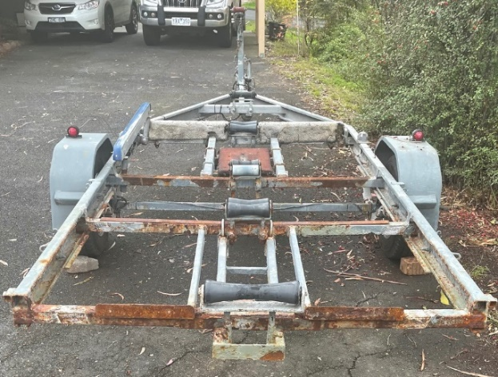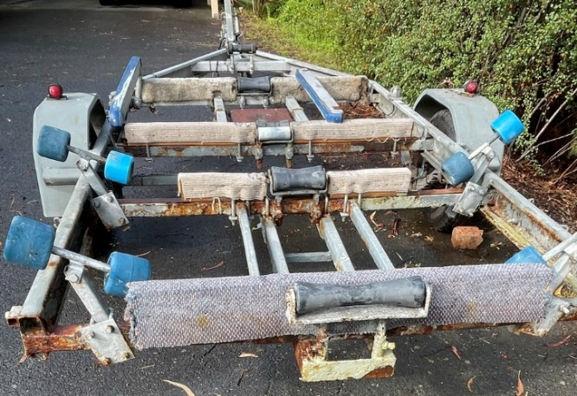

I then examined the last three back cross members (see above) of the trailer only to find that they too had rusted through in numerous places. The cross beams prior to the axle remain in good order so I went to the local welder and discussed the possibility in replacing the back three beams. The welder acknowledged that the trailer could easily be repaired at a sixth of the price of a new trailer.
Before the trailer could be repaired the first job was to remove all the slides, and side paddings attached to the beam down the centre of the trailer abutting the rollers. All the bolts were badly rusted so each bolts had to be heated with a blow torch before unbolting or cutting off with a grinder.
There was no problem in replacing all the back beams and reinforced them both on the side C Section with a larger plate within the C section, and a further small plate from the top of the C Section to the new beam completing a small triangular attachment. See below photographs.

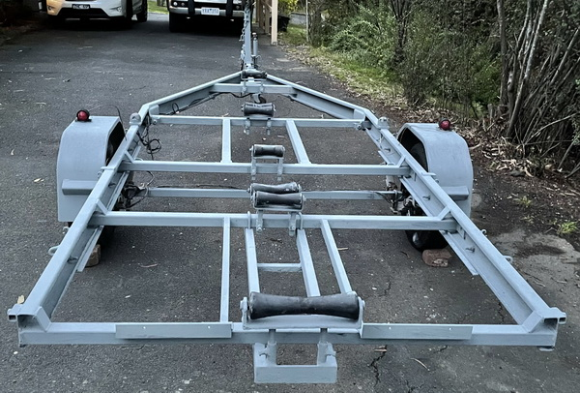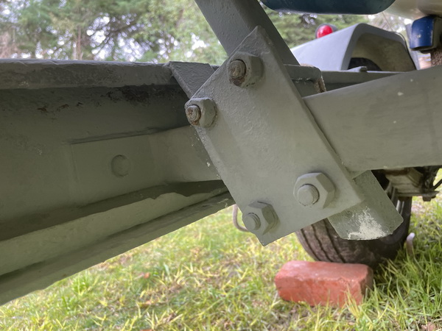

The job was to remove all the excessive rust from the remaining trailer. This was done with a wire brush, circular wire brush on a drill and a nibbler. Following cleaning, the trailer was painted with rust converter then cold gal paint, two coats. Alternatively, I could have got the trailer hot dip galvanized, but that would have cost a lot due to lifting, cartage to and from Galvanisers by tray truck and the need to remove axle wheels and springs.
The next job was to rebuild the slides, beam padding and the rollers in readiness for the boat. Although I took measurements of roller heights etc prior to dismantling I found that I had to level the trailer and ensure the rollers were level on the trailer as well as height.
Finally, the rollers were greased, wheels were removed bearing checked/replaced and greased in readiness for the new season ahead. Total cost was approximately $1200.

Another look at MOB recovery Richard du Moulin, Storm Trysail Club
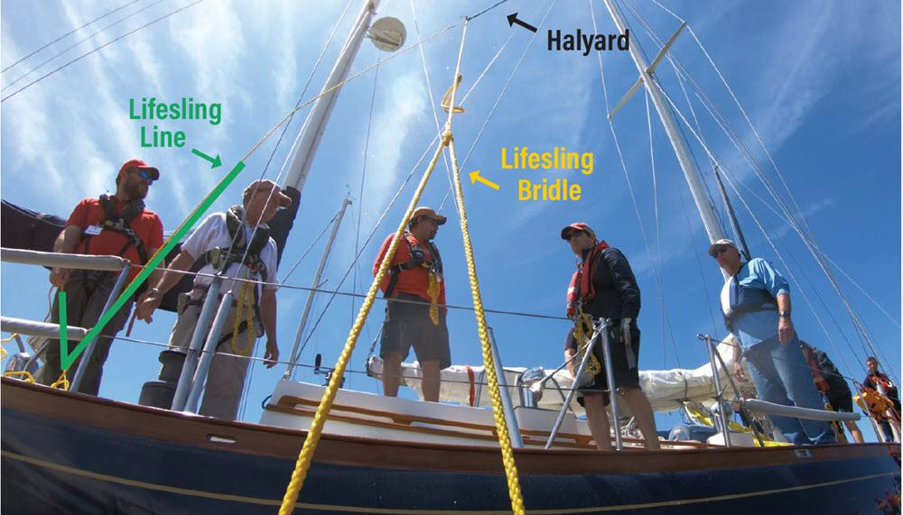

For the past thirty years, leading sailing organizations like the U.S. Naval Academy, US Sailing, Seattle Sailing Foundation, Cruising Club of America, and the Storm Trysail Club have developed best practices to maneuver back to and attempt to recover a man overboard (MOB).
The Storm Trysail video, Safety-At-Sea: Man Overboard Recovery, is probably the best video production of MOB practices, combining footage from on-the-boat, off-the-boat, drone, and a helmet-mounted GoPro camera worn by the MOB. In that video, various methods of approaching (returning to) and recovering (hoisting on deck) the MOB were demonstrated.
However, recent fatalities and new practices make it an urgent priority to revisit approaching and recovering an MOB in more detail and introduce a few new ideas. Two major challenges to a successful outcome have become more apparent:
- The risk of the boat fatally striking the MOB during the approach and recovery, and
- The difficulty of lifting the MOB up on deck.
Getting back to the MOB safely
Using the engine is critical to enable the yacht to return to the MOB promptly and make the first approach successful. Too many documented MOB incidents have seen up to four approaches without the assistance of an engine, where the MOB is OK on the first failed attempt but ends up a fatality due to further exposure or being run over by the yacht. All crew should know how to start the engine.
The operating characteristics of modern, high performance yachts increase these difficulties. Their sailing speed results in greater separation from the MOB, particularly downwind. When trying to motor back to the MOB, these designs are often underpowered, displaying poor handling under both power and sail at low speed.
Their light displacement and narrow, high aspect keels increase the risk of the bow falling off and striking the MOB. Narrow rudders and smaller propellers – often retractable and located far forward from the rudder – reduce steering control. Dual rudders do not line up with centerline propellers, eliminating the prop wash necessary to steer at slow speeds.

Even conventional displacement yachts – with more engine horsepower and easier steering at slow speed– can run down the MOB, especially at night in rough water. Know the steering characteristics of your
boat, especially at slow speed.
If the yacht can operate well under power in the conditions, in addition to the spinnaker or jib, the mainsail should also be doused. If the main (or jib) is needed to assist the return to the MOB, the douse can be delayed.
When the MOB is spotted, the life-sling is deployed and the yacht motors just fast enough to maintain good steerage – maybe 3-4 knots (test your own yacht) – and passes close (about 15 feet) to leeward of the MOB, turning sharply so the MOB can make contact with the life-sling. The yacht then uses full power to stop dead in the water about two or three boat lengths away, but not dead upwind out of fear of drifting down onto the MOB.
Recovering the MOB – A New Idea: the Mid-Line Lift
Regardless of whether the yacht is conventional or high octane, lifting the MOB safely on deck is difficult due to the freeboard and wave action. It is most dangerous on yachts with chines or hull flare where the MOB can slide under the hull. Using a life-sling eliminates the need to make direct contact with the MOB. However, pulling the MOB immediately alongside can put the MOB in danger of injury.
Here’s a new idea: Instead of the crew immediately pulling the MOB alongside, leave the life-sling line cleated aft at the stern. Then, preparing for a Mid-Line Lift, walk a spinnaker halyard aft and clip it onto the life-sling line, outside the lifelines.
As the halyard is taken up, the halyard shackle slides out on the life-sling line, and the MOB is pulled up- wards (about half out of the water) and towards the yacht. As the MOB reaches the yacht, the MOB is lift- ed into the air to be grabbed by the crew. At no time is the MOB free-floating and vulnerable alongside the yacht.
Fitting out your yacht for the Mid-Line Lift
The Mid-Line Lift has a 1:2 mechanical disadvantage, but most yachts have winches and crew strong enough to recover the MOB. The initial hoisting that brings the MOB near the yacht is quite easy. The final ten feet gets more loaded as the MOB is lifted out of the water.
Double-handed sailors, whether racers or cruising couples, might be more challenged if the remaining crew on board is not strong, or if the winches are underpowered. If practice confirms this, the Mid-Line Lift might need to be replaced by a 1:1 setup where the MOB is pulled in to about 30 feet from the yacht, then the halyard is secured to a previously tied loop. While not as effective as the Mid-Line Lift, this setup re- duces the time the MOB is floating alongside before being hoisted.
To properly size the life- sling line for a Mid-Line Lift, it must be a few feet shorter than twice the height of the spinnaker halyard sheave off the water. Otherwise, the 1:2 setup will cause the halyard to two-block as it reaches the masthead before the MOB is on deck. There’s no need to cut the life sling line. It can be cleated at a marked location and the remainder hanked up.
Replacing the yellow life sling line with 6mm floating spectra can add extra strength and resistance to sun and abrasion. No yellow life sling line has parted during our drills, but the Mid-Line Lift does create extra load.
Most halyard shackles slide easily along the line, but you can also fit a sliding loop with a short strop onto the line. Make sure to secure the loop with a quick
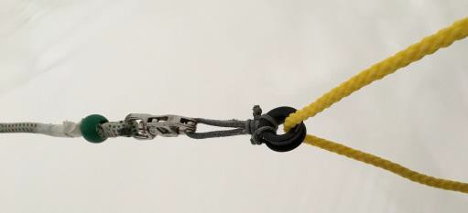
release knot next to the end of the line at the stern cleat so it is easily available when needed. Also, check your spinnaker halyards to ensure they are long enough to reach the stern of the yacht to clip onto the line (or loop).

Spinnaker halyard snapped into sliding loop
If the MOB is Incapacitated
When the MOB is unconscious, injured, hypothermic,
or weak and unable to grab the life sling – this is when the amateur crew is at a disadvantage. Many professional yachts have a trained Rescue Swimmer – connected to the boat with a safety line – who can reach the MOB and together get Mid-Line Lifted.
Without a professionally trained Rescue Swimmer, the amateur yacht must maneuver much closer, adding some degree of risk, and lower a Rescue Crew on a halyard into the water to secure the MOB. This Res- cue Crew is best equipped with a climbing harness, helmet and Rescue PFD. This style PFD is less cumbersome than an inflatable and has a safety ring on the back for a tether.
Techniques to secure the MOB include using a tether, a second halyard, life sling, Gale rider drogue, or even bear-hugging the MOB. To watch the crew of the 100-foot Comanche perform a Mid-line Lift with a Rescue Swimmer, go to ussailing.org/education/adult/safety-at-sea-courses/safety-at-sea-resources/
#comanche.
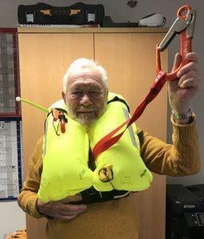
In practices and real MOB situations, we find it is difficult to attach a halyard or tether to the D-rings of the PFD because the inflated chambers block the D-rings on most models. Some new PFDs have a dedicated lifting strap built into the unit. For the Clipper Race, Sir Robin Knox-Johnston fits permanent lifting straps to the webbing of the PFD. Make sure your PFD has an easily accessed lifting point.
Figure 1Sir Robin Knox-Johnston demonstrates the
Practice with your crew on your yacht
A yacht owner/skipper is the Responsible Party with traditional and legal responsibilities to plan for the safety of the yacht and crew.
Sir Robin Knox-Johnston demonstrates the fitting straps permanently attached to the webbing of his inflatable PFD

The Cruising Club of America just published an excellent one-page “Culture of Safety” statement (cruisingclub.org/article/ safety-culture) that is worth reading. Customized MOB evolutions for your yacht and crew must be developed.Serious practice is required to evaluate your yacht’s characteristics under sail and power, especially at slow speed and maintaining position.
It is strongly recommended that before going offshore, a crew should practice about four hours of upwind and four hours of downwind recoveries using a tallboy buoy that is easy to pick up and doesn’t blow downwind like a cushion. Initial practice should be in medium breeze and then work up to heavy air and night. Try fitting an AIS or strobe to the tallboy.
Use life sling approaches to make contact with the “tallboy MOB” as if it were an MOB. Also try to maneuver alongside to test your yacht’s handling characteristics and improve your skills for picking up an incapacitated MOB.
At the mooring or dock, two hours of Mid-Line Lift and other recoveries should be practiced with a real
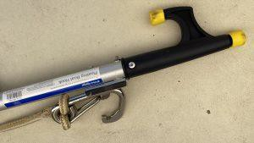
MOB wearing an inflated PFD. With your Rescue Crew lowered on a halyard, test the various alternatives to recover an incapacitated MOB. Life Raft + Survival Equipment (lrse.com) sells a very useful Jacobs-style ladder that pro- vides a good backup.
Finally, head for the bar and take with you two (yes, you should have two) throw bags and pair your crew up on the lawn for a “Throw Bag Duel at 20 Paces.” Great way to practice a backup method to get a line to an MOB!
Another useful tool for snagging an incapacitated MOB is a mooring hook (Wichard makes a good one) attached to a pole or boat hook.

With all the crews’ input, an MOB Plan should be drafted and posted that reflects what works best for your yacht, and has been understood and practiced by your crew. If you’d like to share your MOB Plan with the Storm Try- sail Club for posting on our new website, please email it to me at rdumoulin@intrepidshipping.com, Attention: Safety at Sea.
Here’s the Doublehanded MOB Plan for my Express 37 Lora Ann:
QUICKSTOP:
- Deploy MOM & Horseshoe
- Hit “MOB” & Lash Tiller
START ENGINE:
- Neutral, Key, Start

IF STARTS  Drop sails/trim sheets Check for lines in water Return near MOB Deploy Life sling  Circle MOB clockwise Upon contact- Stop Lash Tiller  Snap halyard to Lifesling line Winch up MOB | IF NOT START  Drop headsail Return near MOB Deploy Life sling  Circle MOB clockwise Upon contact- Luff up Lash tiller  Drop mainsail/trim sheet Snap halyard to Life sling line Winch up MOB
Spinnaker:
- Quick Stop if light-medium wind.
- If breeze: MOM & Horseshoe, wiggle course,
- Hit “MOB”, douse, motor (sail) back.
- Douse jib/main on port side (to clear starboard deck)
- Circle MOB clockwise (my Life sling is set up to starboard)
- When MOB has Life sling, stop where boat does not drift onto MOB
- MOB: if dragging on Life sling, roll onto back
(If MOB dragging on tether: stop boat; snap halyard on tether and hoist)
What if you are the MOB?
During Storm Trysail MOB research, some of the best videos have been from the GoPro camera mounted on A helmet worn by the MOB. Our “volunteers” have also made interesting observations.
If the inflatable PFD doesn’t inflate automatically, remember to pull the manual inflation tab. Make sure you know where yours is located! You must know how to maintain and operate your PFD! If manual inflation
fails, try the oral inflation tube – best done floating “comfortably on your back” (easier said than done). Better solution: Go back to step one and learn how to maintain your PFD!
Tighten your crotch straps to elevate your mouth above the water. Check that your strobe is functioning. Hold the AIS in the air for better transmission. If the water’s choppy, pull on the hood/face shield and face downwind.
Your whistle might be your most important communication asset. The piercing sound travels well and has saved many lives. When the yacht is in sight, splash your arms calmly to make it easier for the yacht to see you and know that you are mobile. When you make contact with the life sling and slide into it, roll over on your back if the yacht drags you too fast.
Dragging by a tether
We have to thank Sir Robin Knox-Johnston for a novel application of the Mid-Line Lift, which is standard procedure in his Clipper Around the World Race. Check that your halyard shackles are large enough to snap over your tethers. If not, clip a standby carabiner at the mast base.
There have been an increased number of incidents where tethered crew have fallen overboard and dragged alongside. This can be fatal. However, it is no excuse for not clipping in! If sailing upwind or jib reaching, the helmsman must immediately luff up in order to slow down and reduce the pressure on the MOB. Luffing also reduces the heel and helps lift the MOB out of the water. An Upwind Quick-Stop leaving the jib aback works very well (once your hikers are off the rail).
Sailing downwind with a spinnaker, in light/medium wind the helmsman can do the Quick-Stop. In heavier wind, bearing off and collapsing the chute may be the safest option. You will know from your hours of MOB practice…right?
In any case, the Mid-Line Lift is the fastest and best method to recover the MOB. Immediately upon discovering a dragging MOB, the crew instantly snaps a halyard onto the MOB’s tether and hoists. The halyard
lifts the MOB out of the water.
Prevention: To avoid the risk of being dragged, always use your short 3-foot tether when working on the lee- ward side of the boat or double your 6-foot tether around the jackline and back to your D-ring. Then you cannot reach the water if you slip. Also use the short tether when changing headsails that can pull you over- board, or when waves can lift you off the foredeck.
Rig your jacklines as far inboard as possible, and if your yacht has a trunk cabin, run a second pair of jack-lines along the cabin top parallel to the grab rail.
All offshore tethers should have a release shackle on the inner end. If you are drowning on the tether, and your yacht is not responding, you might have to make the awful choice of pulling the shackle and becoming a full-on MOB.
Credits
Thanks for the very important inputs from: Stan Honey (Navigator, Comanche); Sally Honey (Chair, US Sail- ing Safety-at-Sea Committee); Chad Corning (Crew, Argo); Chuck Hawley; Dick York; Buttons Padin; Adam Loory; swimmer/MOB Gerard Girstl; Kelly Robinson; Jim Murphy and the crew of Inisharon; and Sir Robin Knox-Johnston.
Author
Richard du Moulin has competed in four America’s Cup campaigns, a Transpacific Yacht Race, a Rolex Sydney Hobart Yacht Race, three Rolex Fastnet Races, six Transatlantic Races, and twenty-five Newport Bermuda Races. In 2003, he and co-skipper Rich Wilson set a new record for the 15,000-mile passage from Hong Kong to New York City aboard the 53-foot trimaran Great American II, eclipsing the time set by the clipper ship Sea Witch in 1849. A member of the Cruising Club of America, Royal Ocean Racing Club, New York Yacht Club, and Storm Trysail Club (Past Commodore), he’s currently serving as Chair of the StormTrysail Foundation. He lives in Larchmont, NY.
Published on April 30th, 2020
Timpenny Association thanks Scuttlebutt Sailing & the author for this input . Check out www.sailingscuttlebutt.com for more articles. It is free.

Victorian Timpenny Titles at Bendigo Yacht Club
1st & 2nd May 2021
After the original titles were cancelled due to Covid epidemic close down in Victoria and then the opportunity to get Bendigo Yacht Club to host the titles management jumped at the opportunity. The week before the titles our President was sailing on the Gippsland lakes when a power boat crashed into his Timpenny 670 doing major damage to this Timpenny 670 boat “Juniper” that made it impossible for him to sail at the Bendigo Regatta.
Six boats fronted up and enjoyed an excellent weekend. Once again Doug Carswell and Ken Mann showed the rest of the fleet how to sail on a lake.

Results
Place | Sail No. | Name | Class | Crew | Race No.
 |  |  |  |  | 1 | 2 | 3 | 4 | 5 | Total Score
1 | 3038 | Uome | 670 | Doug Carswell  Ken Mann | 1 | 1 | 1 | 1 | 1 | 3
2 | 3941 | Aussie  Action | 670 | Rob Milner  Ian Rice | 4 | 2 | 2 | 2 | DNF | 6
3 | 3034 | Bea Jay | 670 | David Marshall  Rowan Gillies | 2 | 3 | DNF | 3 | 3 | 8
4 | 3016 | Sixpenny Bit | 670 | Ron Mason  Warren Matheson | 6 | 5 | 3 | 6 | 2 | 10
5 | 3092 | Windancer | 670 | Dennis Scammel Bentley Scammell | 3 | 4 | 4 | 5 | 5 | 11
6 | 3078 | Nartanda | 670 | James Mahony | 5 | DNF | 5 | 4 | 4 | 13

THE SCIENCE BEHIND YOUR SAIL TRIM – North Sails

Induced Drag and Mainsail Leeches
By Tom Whidden
One of the goals for our book, The Art and Science of Sails, is to connect the theoretical with the practical. An understanding of the physics of aerodynamics will help us better trim and set our sails. To illustrate this, I’ve chosen a seemingly obscure topic – induced drag and how to minimize it – by splicing together a few excerpts from my new book.
As a tactician, I need to ensure the boat is fast. Otherwise, we’re not going to win, regardless of how well I do my job. And, since the main was always front and center for me, I was constantly studying it, ensuring my mainsail trimmer was doing his/her job. I hope the following will help you better understand the connection between the science and sail trim—and there’s plenty more detail in the book.
By far the largest and most destructive drag for sailing performance is induced drag. The root cause of induced drag is the changing of the direction of the air flow by the foil. With airplane wings that change is downward; with a sail it’s to weather. The change in flow direction is the beginning of the process of lift.
So, induced drag is a direct result of the creation of lift. In more technical terms, induced drag is the varying coefficient of lift (Cl) across the span. In other words, the differences in lift across or over the total area of a sail or wing cause induced drag.
How does induced drag relate to real life on a sailboat? Assuming the boat is well trimmed and properly set up, about 80 percent of the total sail area will experience relatively constant Cl. However, in the aftermost 20 percent of the sail, the velocity of the flow rapidly decreases; and with it, the lift. The rapidly changing Cl results in significant induced drag, some on the leech and some at the head and foot. This induced drag forms the vast majority of the total drag.
There are two variations of induced drag:
- off the trailing edge (leech)
- off the tips (head and foot)

Induced Drag off the Leech
These are vortices, spinning counterclockwise-off that trailing edge. A deeper head section, compared to the bottom, minimizes the flow of air trying to find the shortest path from the high-pressure windward side to the low-pressure leeward side.
Leech twist is very significant for the optimization of upwind speed. It’s been said that the only reason to have a front of a main is to be able to attach the leech area to the mast! The leech of the main not only ensures that the air bent around the front of the main is allowed to exit with the least interference (induced drag), but also to help steer the boat.
So, how should the trimmer adjust the leech to best attain the above two goals while sailing upwind? With a well-designed and relatively new main, the answer is to sheet the main until the top telltale (preferably hanging off the back of the top batten) just begins to stall. If it’s constantly stalled (hidden to leeward), it’s a sign drag is too high. The lift-to-drag (L/D) ratio is lowered. If the telltale is flying straight back or there is an excess of backwind, it’s a sign that the sail could be sheeted tighter to allow the boat to sail closer to the wind. In this case, the L/D ratio is reduced for the opposite reason.
This screen shot, from a RANS-code CFD analysis, illustrates the tip vortices emanating primarily from the top leech of the main on a fractional-rigged boat. The orientation is looking back at the top of a rig and sails from just to leeward and forward of the onset flow.

Induced Drag off the Head and Foot
The second variation in induced drag is tip vortex. On a plane, these flow off the ends of the wings; on a sail, they flow off the head and foot. There is a pressure difference, or delta, from the lee side of the sail to the windward side. Nature abhors pressure deltas. It’s why we have wind. And, it’s why the flow on the high-pressure side of a sail wants to escape over the top or end to help equalize this pressure.
Almost all modern race boats employ a fractional rig. At the hounds, the main’s chord on the fractional rig is still quite long and therefore helps shed the headsail’s tip vortices. On a masthead rig, the tip vortices of the headsail are matched with the tip vortices of the mainsail. Not good!

